# Event Object - Passing Parameters

## Nodejs code

### Parameter is language

const moment = require('moment');

const thanks = {

"en": "Thank you, Thanks",

"fr": "Merci",

"hi": "Dhanyavad",

"es": "gracias",

"jp": "arigato",

"ru": "spasiba",

"it": "Grazie",

"gr": "danke"

}

// Async handler

exports.handler = async (event) => {

// path parameter

let name = event.pathParameters.name;

// query parameter

let {lang, ...info} = event.queryStringParameters || {};

let message = `${greeting[lang] ? thanks[lang] : greeting['en'] } ${name}`;

let response = {

message: message,

info: info,

timestamp: moment().unix()

}

return {

statusCode: 200,

body: JSON.stringify(response)

}

}

## Visual Studio Code

npm install

npm init

npm install moment

## Path Parameter / Query parameter

## Deploy function

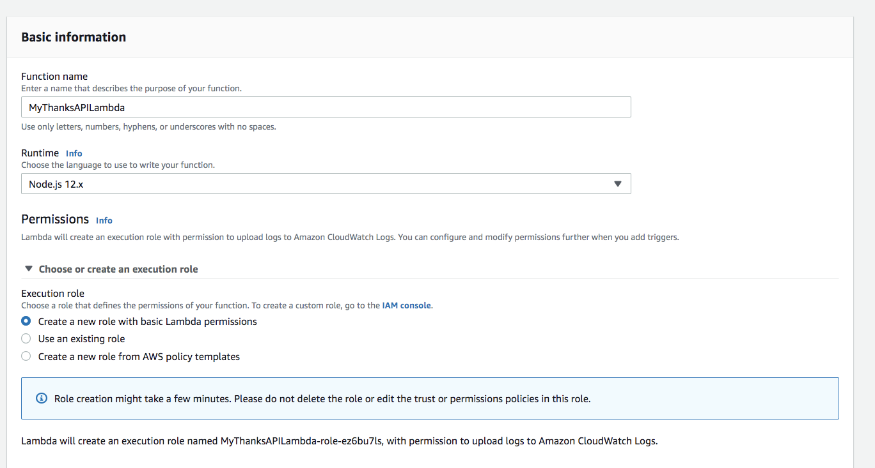

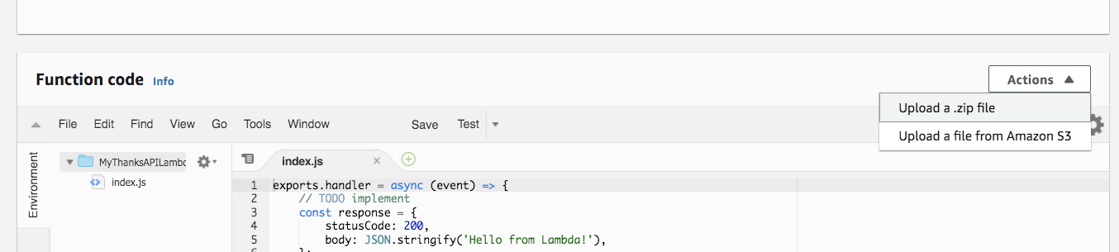

## Test the event from API Gateway

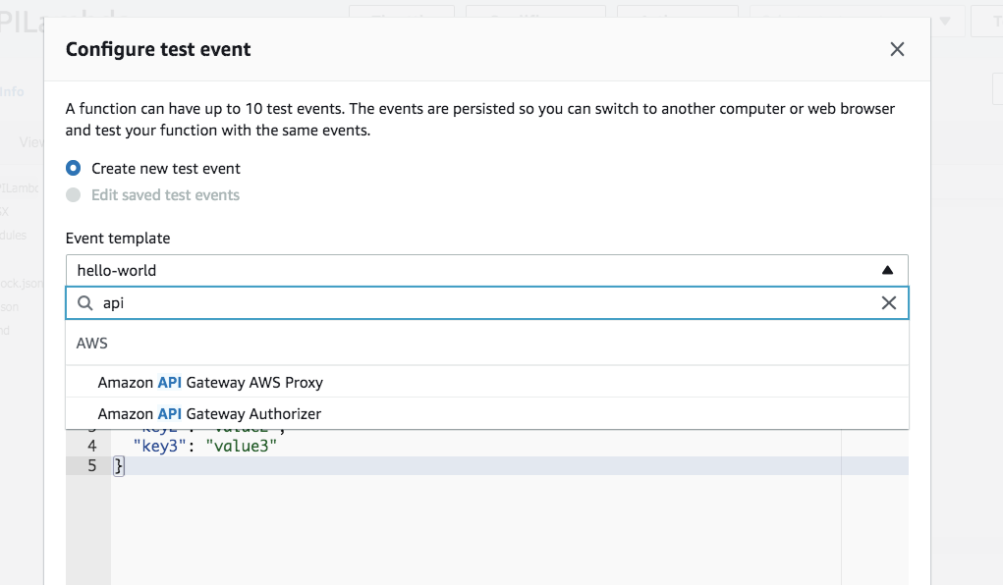

{

"body": "eyJ0ZXN0IjoiYm9keSJ9",

"resource": "/{proxy+}",

"path": "/path/to/resource",

"httpMethod": "POST",

"isBase64Encoded": true,

**"queryStringParameters": {**

**"lang": "fr"**

**},**

"multiValueQueryStringParameters": {

"foo": [

"bar"

]

},

**"pathParameters": {**

**"name": "NFJSThanks"**

**},**

"stageVariables": {

"baz": "qux"

},

"headers": {

"Accept": "text/html,application/xhtml+xml,application/xml;q=0.9,image/webp,*/*;q=0.8",

"Accept-Encoding": "gzip, deflate, sdch",

"Accept-Language": "en-US,en;q=0.8",

"Cache-Control": "max-age=0",

"CloudFront-Forwarded-Proto": "https",

"CloudFront-Is-Desktop-Viewer": "true",

"CloudFront-Is-Mobile-Viewer": "false",

"CloudFront-Is-SmartTV-Viewer": "false",

"CloudFront-Is-Tablet-Viewer": "false",

"CloudFront-Viewer-Country": "US",

"Host": "1234567890.execute-api.us-east-1.amazonaws.com",

"Upgrade-Insecure-Requests": "1",

"User-Agent": "Custom User Agent String",

"Via": "1.1 08f323deadbeefa7af34d5feb414ce27.cloudfront.net (CloudFront)",

"X-Amz-Cf-Id": "cDehVQoZnx43VYQb9j2-nvCh-9z396Uhbp027Y2JvkCPNLmGJHqlaA==",

"X-Forwarded-For": "127.0.0.1, 127.0.0.2",

"X-Forwarded-Port": "443",

"X-Forwarded-Proto": "https"

},

"multiValueHeaders": {

"Accept": [

"text/html,application/xhtml+xml,application/xml;q=0.9,image/webp,*/*;q=0.8"

],

"Accept-Encoding": [

"gzip, deflate, sdch"

],

"Accept-Language": [

"en-US,en;q=0.8"

],

"Cache-Control": [

"max-age=0"

],

"CloudFront-Forwarded-Proto": [

"https"

],

"CloudFront-Is-Desktop-Viewer": [

"true"

],

"CloudFront-Is-Mobile-Viewer": [

"false"

],

"CloudFront-Is-SmartTV-Viewer": [

"false"

],

"CloudFront-Is-Tablet-Viewer": [

"false"

],

"CloudFront-Viewer-Country": [

"US"

],

"Host": [

"0123456789.execute-api.us-east-1.amazonaws.com"

],

"Upgrade-Insecure-Requests": [

"1"

],

"User-Agent": [

"Custom User Agent String"

],

"Via": [

"1.1 08f323deadbeefa7af34d5feb414ce27.cloudfront.net (CloudFront)"

],

"X-Amz-Cf-Id": [

"cDehVQoZnx43VYQb9j2-nvCh-9z396Uhbp027Y2JvkCPNLmGJHqlaA=="

],

"X-Forwarded-For": [

"127.0.0.1, 127.0.0.2"

],

"X-Forwarded-Port": [

"443"

],

"X-Forwarded-Proto": [

"https"

]

},

"requestContext": {

"accountId": "123456789012",

"resourceId": "123456",

"stage": "prod",

"requestId": "c6af9ac6-7b61-11e6-9a41-93e8deadbeef",

"requestTime": "09/Apr/2015:12:34:56 +0000",

"requestTimeEpoch": 1428582896000,

"identity": {

"cognitoIdentityPoolId": null,

"accountId": null,

"cognitoIdentityId": null,

"caller": null,

"accessKey": null,

"sourceIp": "127.0.0.1",

"cognitoAuthenticationType": null,

"cognitoAuthenticationProvider": null,

"userArn": null,

"userAgent": "Custom User Agent String",

"user": null

},

"path": "/prod/path/to/resource",

"resourcePath": "/{proxy+}",

"httpMethod": "POST",

"apiId": "1234567890",

"protocol": "HTTP/1.1"

}

}

## Test the Lambda function

## API Gateway: Thanks resource

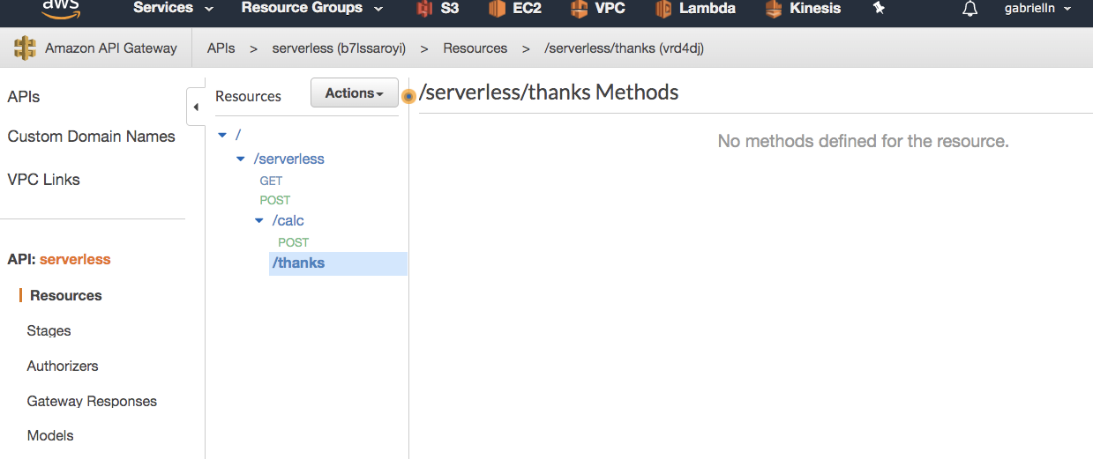

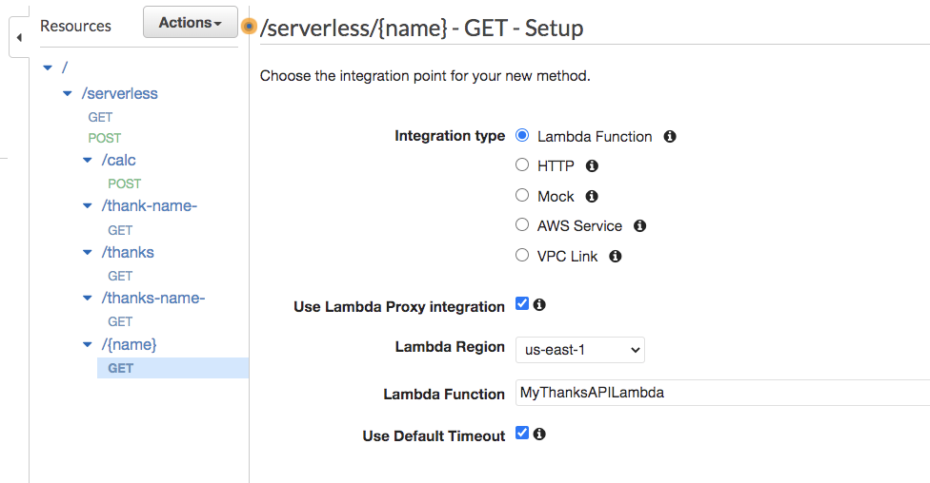

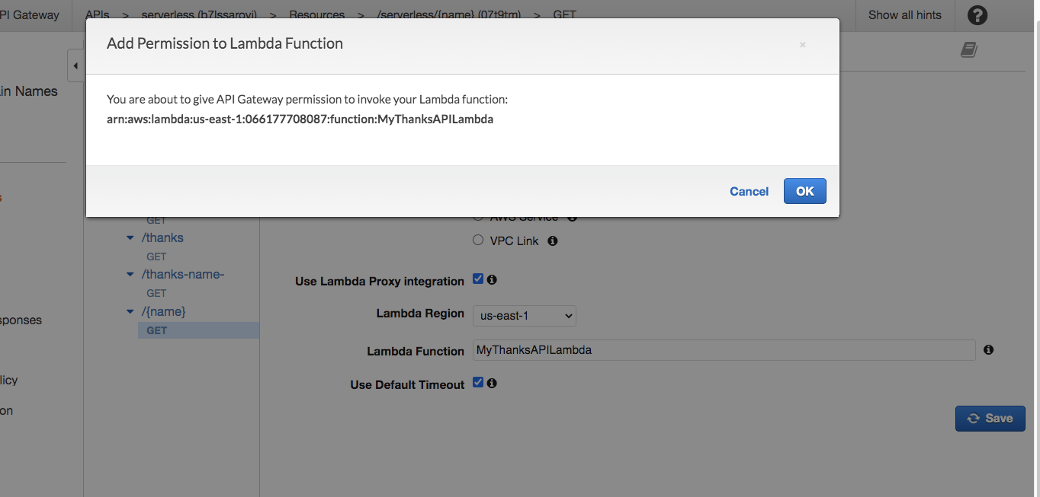

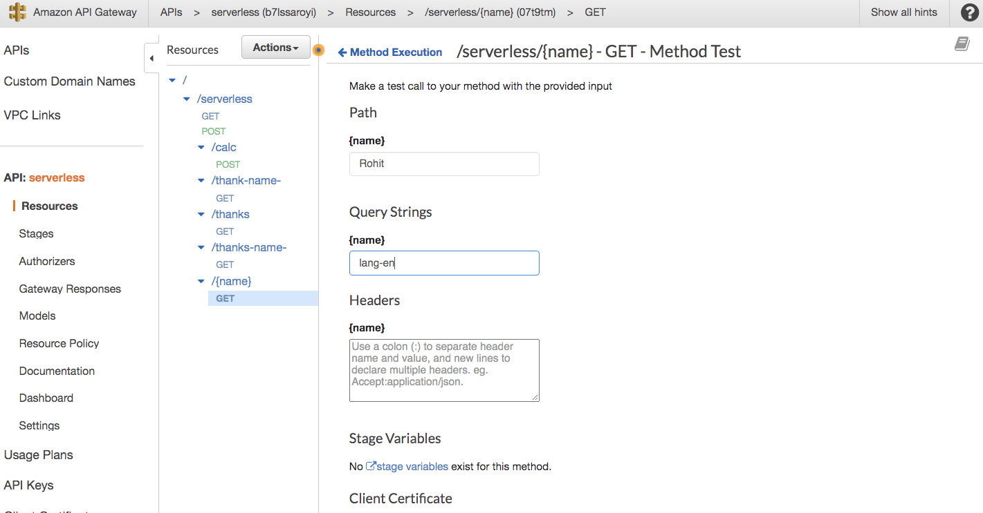

## Test the function

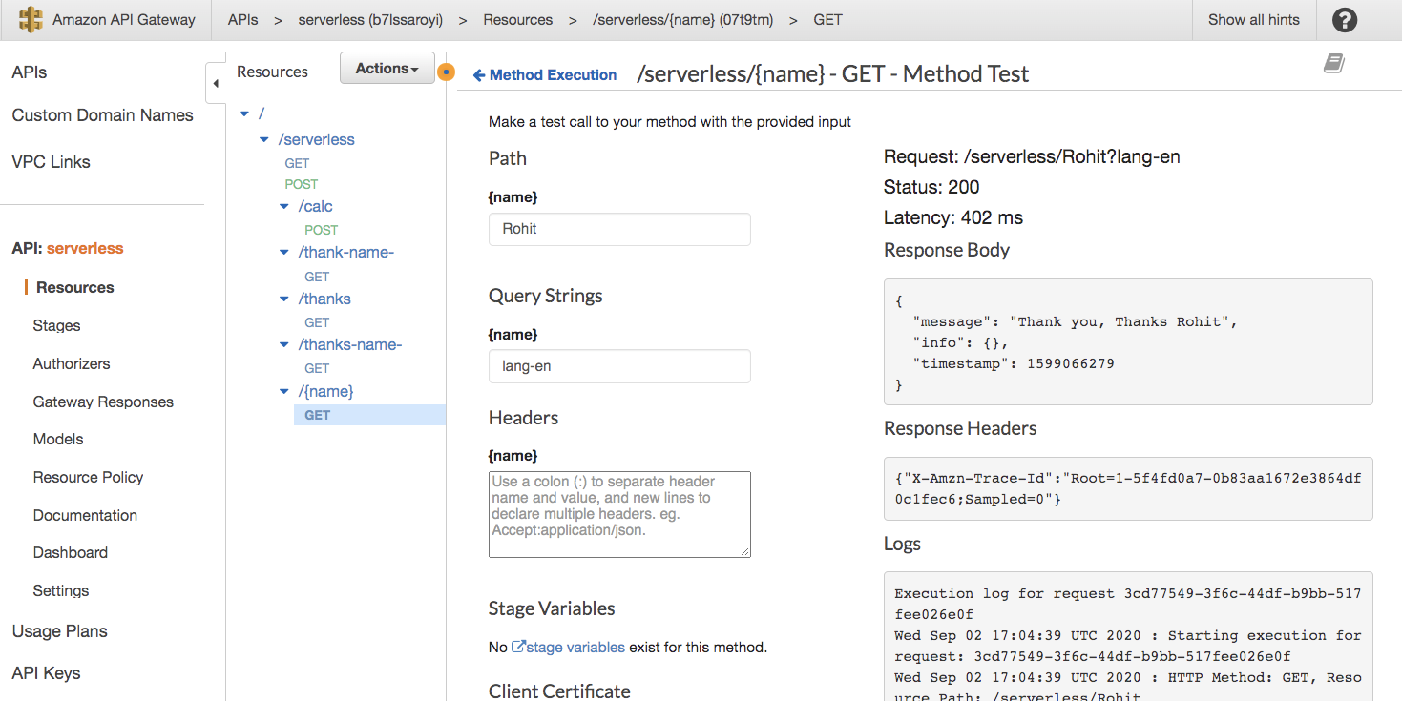

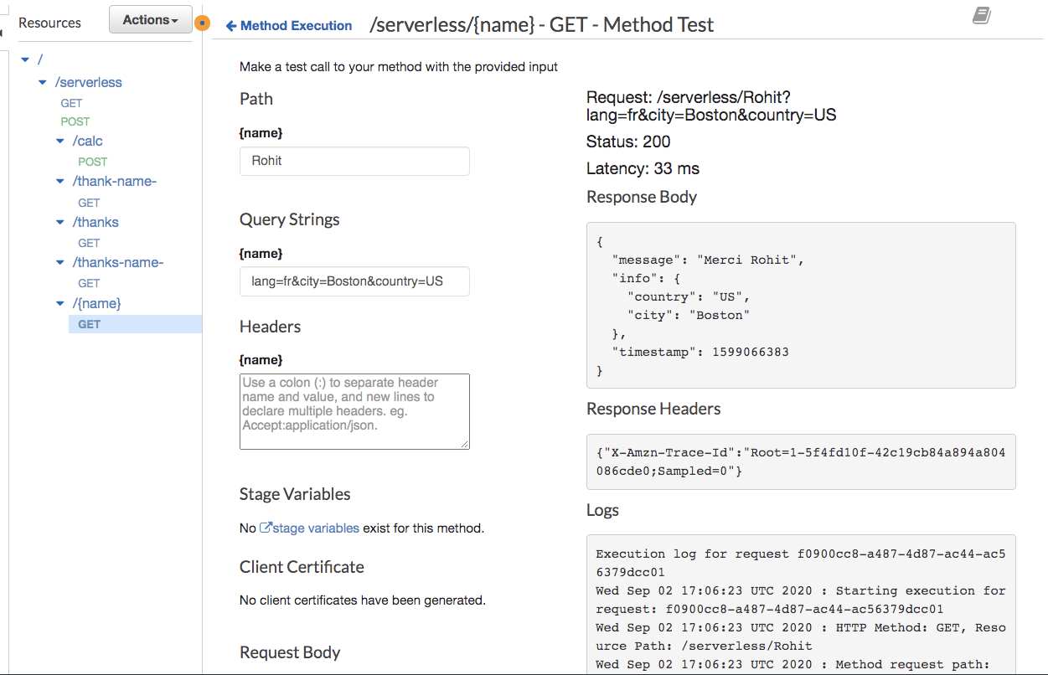

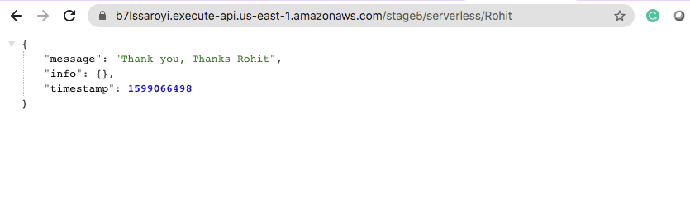

## Passing lang

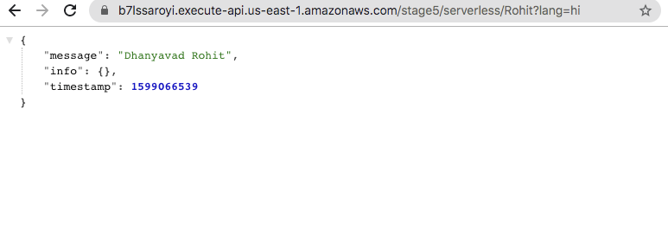

## Call using Postman

## Try existing endpoint

<https://b7lssaroyi.execute-api.us-east-1.amazonaws.com/stage5/serverless/Rohit?lang=hi>